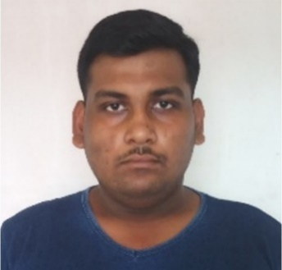

**FINAL YEAR PROJECT**

**Development of a smart wildlife protection system using embedded system & sensor networking**

Work as an active member in a group of four people and contributed in coding of Arduino IDE and JAVA script also work for circuit development.

**EXPERIENCE**

**Web Developer** **2020-2021**

SRKP Technologies, Uttarpara, WB

Work as Frontend Developer, Maintain, update & improve existing company websites.



+91-97481-70968

**CONTACT**

**SKILLS**

HTML, CSS, JavaScript, PCB designing.

◼◼◼◼◼

MS Word, MS Excel

◼◼◼◼◼

Python, C, Arduino IDE

◼◼◼◼◼

**ACHIVEMENTS**



Howrah, West Bengal



nandysubhrajit12@gmail.com

**HOBBIES**

**LANGUAGES**

ENGLISH

◼◼◼◼◼

BENGALI

◼◼◼◼◼

HINDI

◼◼◼◼◼

**Completed** IT smart from APLL with grade (**\***).

**Participate in** “Technosphere” in 2018 & 2019 & in “ROXEC” in 2018.

**Complete Diploma** on synthesizer with 1st Division from “Bangiya Sangeet Parishad” in 2015, on painting diploma & from Bengal Painter’s Association with 1st division in 2012.

**Publish an article** in ‘INTERNATIONAL JOURNAL OF ENGINEERING & ADVANCE TECHNOLOGY’ on 2020.

**EDUCATION**

**B.Tech. Electronics & Communication**

**Engineering (MAKAUT)** **2021-present**

St. Thomas College of Engineering, Khidirpur, WB

**DIPLOMA in Electronics & Telecommunication**

**Engineering (WBSCTVEST)** **2017-2020**

TPI, Hooghly, WB

**SECONDERY (WBBSE)** **2011**

Uttarpara Model High School, Uttarpara, WB

**HIGH SECONDERY on Commerce (WBCHSE)** **2011-2013**

Bally Jora Aswatthatala Vidyalaya, Bally, WB

**B.COM (Hons.) (CU)** **2013-2016**

Lalbaba College, Belur, WB

Seeking a challenging role at a reputed organisation to utilize my engineering skills that can contribute to the company’s growth as well as enhance my knowledge by exploring new things.

**SUBHRAJIT NANDY**